Sid Bhatia

MGT451

Professor Suchow

12/14 September 2023

**Lecture #2 & 3 Notes – On Reasoning About What Might Have Been**

*When Less is More, The Setup:*

* Assumptions of *homo economicus* model:
  + More is better, better is better.
  + What others get shouldn’t matter.
  + What might have been shouldn’t matter.
* Aim to **maximize utility**.

*However…*

* Which one is worse, missing a flight by 5 minutes and watching it pull away from the gate without you, or missing the same flight by 30 minutes? (Kahneman & Tversky, 1982).
  + Missing by 5 minutes induces many counterfactuals and what you could’ve done better.

*When Less is More, The Study…*

* Gold medalists end up being the happiest.
* Bronze medalists on average are **happier** than silver medalists on average.
* Idea for “why?” goes behind counterfactuals, e.g. “but-for causation”
  + Silver medalists look back at all the little things that they failed to become first.
  + Bronze medalists appreciate just being on the stand.

*Casual Graphical Models (“Bayes Nets”)*

* 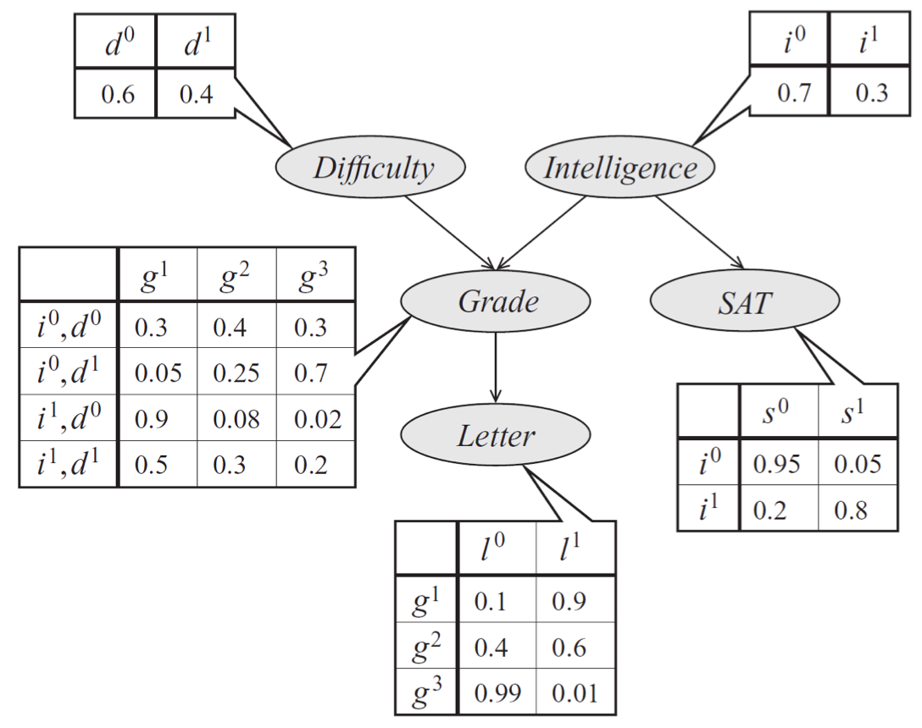
* One of the primary reasons to use casual graphical models is that you can represent joint probability events without writing out each outcome.

*What is an Intervention?*

* As an experimenter, you have control over some aspects of it.
  + In context to **CGM**, you set the outcomes of the node to some outcome.
* There is **hard intervention** and **soft intervention** as well.
  + Soft = not fully able to set outcome, therefore changing/shifting probabilities of outcomes.

*What is a Counterfactual?*

* It involves thinking about what happens if things are different.